Name: Callejo, Jaff Raine Jay V. Date: November 27, 2025
Course, Year and Section: BSIT-2A
Assembly Programming
Case Study 2: Even or Odd Checker
Screenshot
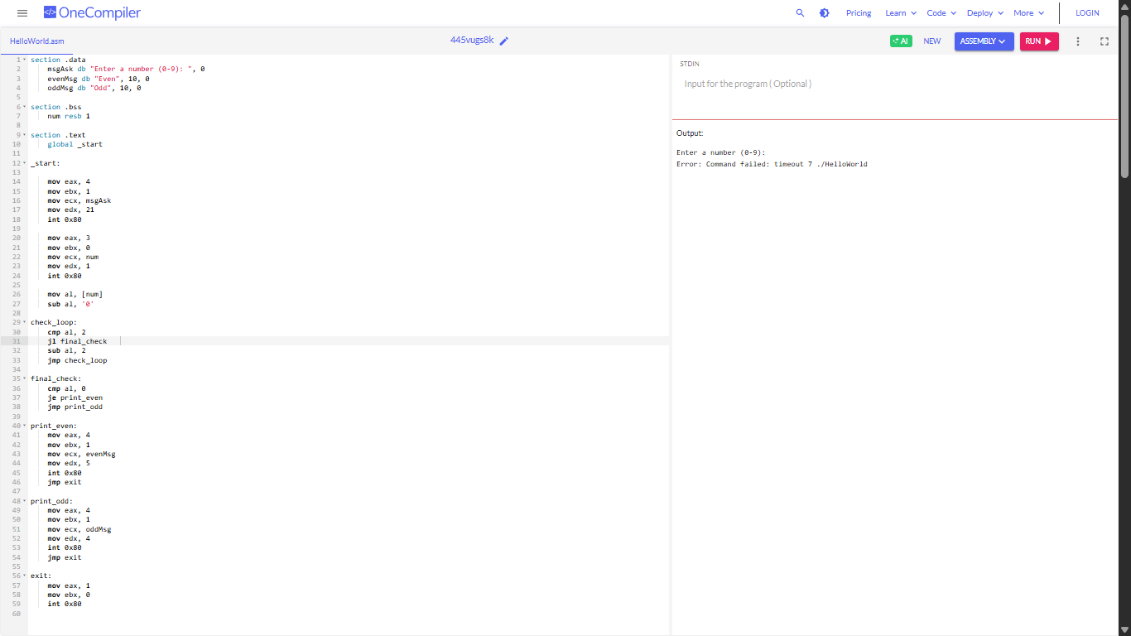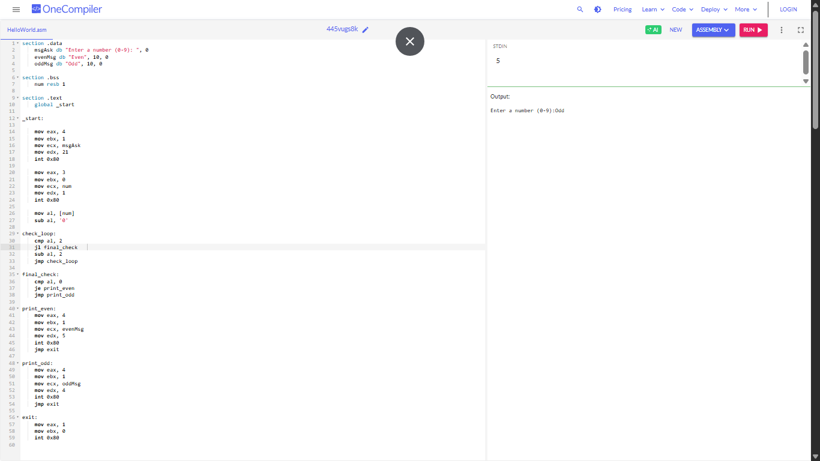
Reflection:
During this activity, I learned how Assembly language works very closely with the CPU, and I realized that even simple tasks require very detailed steps. I got to practice using registers, system calls, loops, and conditions, which helped me understand how the computer processes instructions one step at a time. At first, the syntax was confusing and very strict, but after trying it out, I slowly understood how each line of code affects the program. I also learned how to check if a number is even or odd using a subtraction loop instead of the usual operators we use in high-level languages. Overall, this activity helped me appreciate how much work Assembly does in the background and how much easier modern programming languages are compared to low-level coding.

